DRAFT

The Hindu Kush Himalaya Hydrological Cycle Observing System

HKH-HYCOS

Standard Operating Procedures

Operation and Maintenance of Hydro-meteorological Stations

Foreword

The International Centre for Integrated Mountain Development (ICIMOD) in collaboration with World Meteorological Organization (WMO), Geneva and national partners in Bangladesh, Bhutan, China, India, Nepal and Pakistan is hosting the Regional Flood Information System in the Hindu Kush Himalaya (HKH-HYCOS) as a regional component of the World Hydrological Cycle Observing System (WHYCOS). This Standard Operating Procedures (SOP) provides a standard working tool that can be used to install and maintain hydro-meteorological equipment under the HKH-HYCOS programme, perform routine management of data collection, quality checking and data transmission.
This document is valid for a period of up to four years from the official date of publication. After four years, this document will be reissued without change, revised, or withdrawn by the HKH-HYCOS programme.
Questions regarding this document should be directed to the HKH-HYCOS Staff at:
Integrated Water and Hazard Management Programme (IWHM)
International Centre for Integrated Mountain Development (ICIMOD)
G.P.O. Box 3226
Khumaltar, Kathmandu, Nepal
EM: iwhm@icimod.org
Tel: +977 1 5003222

Table of contents

Foreword i
Table of contents iii
Acronyms iv
1 Purpose 1
2 Who Should Use the SOP? 1
3 Disclaimer 1
4 References 1
5 Definitions 2
6 Maintaining the Station 2
7 Hotlines for maintenance 3
8 Overview of the HKH-HYCOS data collection and transmission process 3
9 Equipments 4
9.1 OTT Radar Level Sensor (RLS) 4
9.2 OTT Compact Bubble Sensor (CBS) 7
9.3 Tipping Bucket (TB3) 11
9.4 OTT Pluvio² 13
9.5 Anemometer –Young Wind Monitor 16
9.6 Barometer PTB210 18
9.7 Barometer PTB330 20
9.8 Temperature / Humidity Sensor - HMP155 with Radiation Shield 22
9.9 Data logger - RTDL-11 24
10 Field Inspection 34

Acronyms
CBS Compact Bubble Sensor
DCP Data Collection Platform
FF Flood forecasting
GND Ground
HKH Hindu Kush Himalayas
HKH-HYCOS Hindu Kush Himalayan Hydrological Cycle Observing System
HYCOS Hydrological Cycle Observing System
ICIMOD International Centre for Integrated Mountain Development
LED Light Emitting Diode
RFIS Regional Flood Information System
RLS Radar Level Sensor
RTU Remote Terminal Unit
RUIM Removable User Identity Module
SDI Serial Data Interface
SIM Subscriber Identity Module
WHYCOS World Hydrological Cycle Observing System
WMO World Meteorological Organization

Standard Operating Procedures

Purpose
This Standard Operating Procedure for the Operation and Maintenance of Hydro-meteorological Instruments applies to those activities that involve the collection of data of various parameters like water level, rainfall, precipitation, wind speed and wind direction, temperature and humidity, pressure etc. The procedures include equipments and site selection factors, installation, operation and field measurement techniques for operation and maintenance of the hydrological stations. These procedures are to be followed to minimize variation and reduce errors and ensure accuracy in measurement of hydro-meteorological parameters.
Once data are acquired, it must be reviewed for quality control by national flood forecasting services in accordance with respective national quality control standards and archived in national and regional data repositories as processed data. Only processed data will be used as credible data for any application, anywhere in the HKH-HYCOS countries (Bangladesh, Bhutan, China, India, Nepal and Pakistan).
Writing for this SOP has been completed incorporating comments of reviewers including national partners and Equipment Expert of Vendor Real Time Solutions Pvt. Ltd. The subject covered in this SOP is not exhaustive and further input is invited from all users.

Who Should Use the SOP?
The primary users of this document will be line agencies, who collect or review and manage hydro-meteorological data for HKH-HYCOS regional flood information system. Other users will include regional and national agencies that collection such data or use the data for resources management. In addition, users of the Line Agencies hydrometric database will refer to the SOP to understand the accuracy of the data that falls within the different standards categories.

Disclaimer
The purpose of this document is to provide information and standards for activities connected with hydro-meteorological data collection and transmission for the HKH-HYCOS programme. The reader is reminded that Brand names of products and manufacturers are used in text and illustrations to describe various equipment operations and is not intended as a recommendation or otherwise of any brand names mentioned.

References
The SOP is organized in accordance with equipments used in the HKH-HYCOS. For each equipment, specific instructions are provided on: Purpose, Site selection, Installation, Connection, Trouble Shooting and Manufacturer contact details. For greater details on equipment, please refer to manufacturer’s website as mentioned in the Manufacturer contact details.

Definitions
- Baud is synonymous to symbols per second or pulses per second. In case of a modem, this corresponds to “tones per second”, and in case of a line code, this corresponds to “pulses per second”. If the Baud rate is 1,200, then the symbol duration time is 1/1,200 second = 1.2 millisecond.
- SDI-12 - "Serial Data Interface at 1200 Baud" - often used to communicate between a data logger and measuring sensor. It is a master-slave configuration, in which the data logger typically acts as the master (SDI-12 Recorder and Interogator) to the data measuring sensors, which are the slaves (SDI-12 sensors). One master can communicate with multiple slaves, so the SDI-12 protocol requires that each device in the serial network be identified with a unique address, which is represented by a single ASCII character. Electrically the protocol is a three wire digital connection – data (SDI 12 Data), ground (SDI-12 GND) and power supply (+Vcc) 12V. The inline data is human readable as the data is transmitted in plain ASCII.
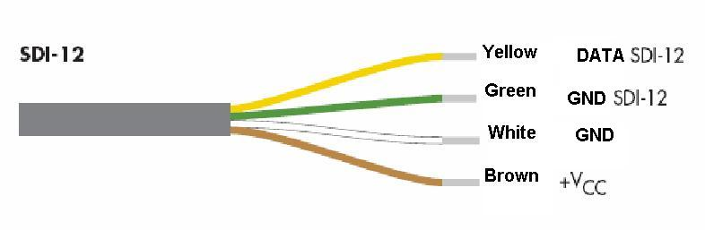
- RS-485 – digital communication standard which offers data transmission speeds of 100 kbit/s at 1200 m.

Maintaining the Station
- To have a station working properly, it is important to respect some basic rules.
- A global cleaning is necessary around the station (housing especially) to give a secure and good access to the house.
- Inside the house, clean regularly (remove dust, insects etc.)
- Cut the grass often
- Clean the solar panel once a week
- Remove dust and leaves from the funnel of the rain gauge
- Maintain an open area around the rain gauge (cut the branches to avoid covering the rain gauge)
- Clean the staff gauges once a month to remove algae and mud
- Check the battery voltage and solar voltage
- Check battery voltage. It must be equal or greater than 12 V.
- Check solar voltage. It must be greater than battery voltage.
- Clean solar panel
- Check if solar panel is covered with dust and clean with water and soft cloth.
- Trim trees, long bushes around the solar panel that is obstructing sunlight falling on the solar panel.
- Check for loose or no connection.

Hotlines for maintenance
Integrated Water and Hazard Management Programme (IWHM)  International Centre for Integrated Mountain Development (ICIMOD)  G.P.O. Box 3226, Khumaltar  Kathmandu, Nepal  EM: iwhm@icimod.org  Tel: +977 1 5003222 | Real Time Solutions Pvt. Ltd.,  Dhobighat, Patan-44600  Lalitpur, Nepal  Phone: +977-1-5538687 / 5529953 Fax: +977-1-5525695  Email: support@wscada.com.np  URL: www.wscada.com/support

Overview of the HKH-HYCOS data collection and transmission process
There are several steps through which HKH-HYCOS operation must proceed in order to satisfy the need for long-term consistent and reliable regional flood forecast (see below).

Project Regional Centre, ICIMOD
National FF Services
Field real-time hydro-meteorological data acquisition
Forecast data
Data processing
Other data
Hydro-meteorological database
Field sensor
Raw data
Preliminarily processed data
Other data acquisition
Hydro-meteorological (GTS etc.)
Soil, Land cover, river schematic
Satellite
Regional Flood Information System
Regional outlook
(Sat. rainfall, Assessment of regional flood trends, Probabilistic forecast, Others)

This document particularly relates to “Field real-time hydro-meteorological data acquisition” procedures. Data processing at the National FF services will follow respective national guidelines. The processed data will be reflected to the Regional flood information system.

Equipments

OTT Radar Level Sensor (RLS)
Purpose |  | 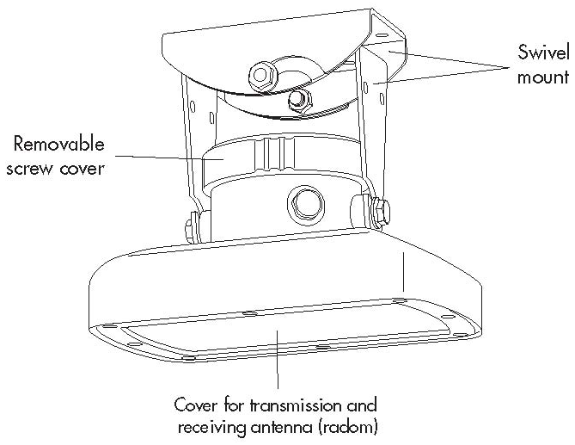  Radar Level Sensor
The OTT RLS is used for contactless measurement of surface water level. It is based on i`mpulse radar technology. The transmitting antenna transmits short radar pulses. The receiver antenna receives the pulses reflected from the water surface and uses them to determine the distance between the sensor and the water surface. The actual water level is then calculated automatically by the radar sensor.
Site selection |  | 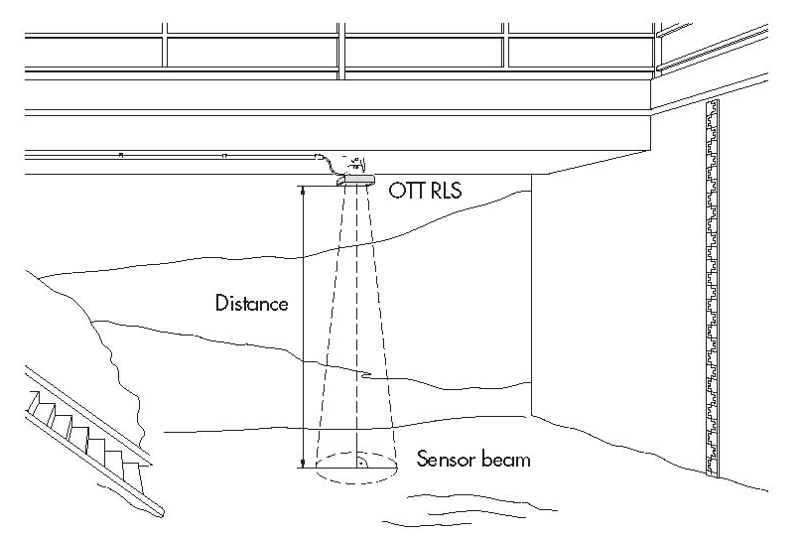  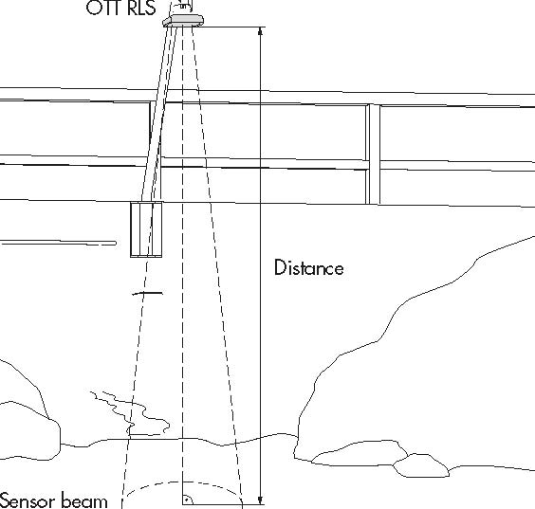
- Possible mounting locations are: bridges and auxiliary constructions directly above the waterway section to be measured; vibrations and movement of the mounting point must be avoided.
- The minimum distance between lower edge of the sensor and water surface must be 0.8 m.
- Select a mounting point high enough so that measurement is possible even with high water levels but ensure that it does not become dry at low water levels.
- The water surface must be as smooth as possible in the area of the sensor beam. Avoid turbulent areas, areas where foam is created, surge occurs and waterway sections where obstructions or bridge piers cause changes in the water level. The measurement result cannot be used if there is ice or snow on the water surface.
- The area within the sensor beam must be completely free of obstructions.
- Avoid large metal surfaces near the sensor beam (reflections from these surfaces can distort the measurement result).
Installation
- Assemble the swivel mount  - Prepare the cable gland  - Remove screw cover and insert connecting cable from RLS to data logger through cable gland.  - Connect the connecting cable to the terminal block.  - Tighten the tightening nut of the cable gland and the screw cover.  - Insert sensor into housing bracket and align the housing parallel (longitudinal and lateral axis) with the water surface.  - Check alignment of the RLS once more.  Note: Ensure no moisture enters the connection area when the screw cover is open! | 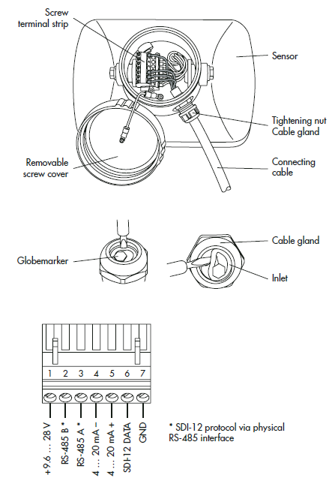  Warning:  The alignment of the sensor parallel to the water surface must be carried out as accurately as possible!  The maximum length of the connecting cable between OTT RLS and data logger is 100 m
Terminal connection | Terminals on RLS
Radar Level Sensor can be connected either to SDI-12 or RS-485 interface.
 | 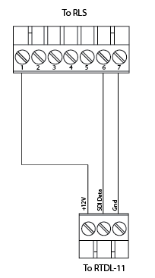  Connecting OTT RLS to RTDL-11 using SDI-12 interface |  | 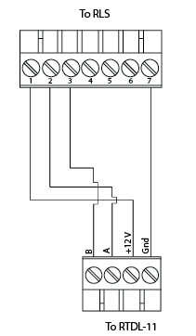  Connecting OTT RLS to RTDL-11 using RS-485 interface
Trouble Shooting
Sensor does not respond to the SDI-12 or RS485 interface | - In case of SDI-12 connection – Check connection assignment  - In case of RS-485 – check A and B wires  - Check if the Polarity of a power supply is reversed - Correct connection assignment  - If Power supply < 9.6 V or > 28 V - check the length and cross-section of the cable  - Ensure that – the sensor is operated with direct current of type 12/24 V DC (e.g. a battery or mains connection with galvanically isolated low safety voltage).
Measured value varies or is not visible | - Carefully clean the sensor (front plate).  - Remove obstruction (if any) in the measurement beam.  - Check and correct (if needed) the Sensor alignment so that it is at right angles to the water surface  - Ensure that the Mounting location of the sensor is steady (e.g. no bridge movement)  - Ensure that large metal surfaces are not near the sensor beam (e.g. piling)
If there is no power supply for more than 60 minutes | - The RLS resets and starts again. (If takes this time until the circuit is voltage-free due to the extremely low power consumption). Settings for the upper and lower value remain unchanged.
Manufacturer | OTT Hydromet Gmbh  Ludwigstrasse 16  87437 Kempten  Tel. +49 (0) 831/5617-222  Fax +49 (0) 831/5617-209  info@ott.com  www.ott.com

OTT Compact Bubble Sensor (CBS)
Purpose | 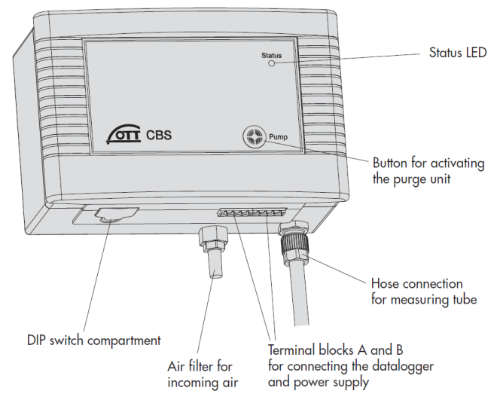  OTT CBS Bubbler
The OTT CBS Compact Bubble Sensor is water level monitoring instrument. Compressed air produced by a piston pump flows via a measuring tube into the water to be measured. The pressure created in the measuring tube is directly proportional to the water column above the bubble chamber.

Connecting the data logger and power Supply | 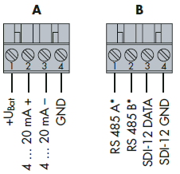  Assignments for Screw Terminal Strip(Terminal Block A and B)
- The protocol used to communicate between Data logger and CBS is: SDI 12; to communicate, only two wires are used (except power sensor power supply)
- See Fig. in the right
Installing the bubble chamber | 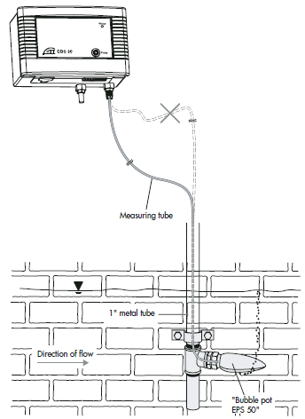  Layout of a level station with OTT CBS bubble Sensor
- Install just below the minimum anticipated water level.
- Avoid areas of the slowest velocity, where fine particles settle out.
- Do not damage or curl the measuring tube during installation.
- Lay the measuring tube so that there is a continuous drop from the CBS towards the bubble chamber.
- Make sure all bends are very wide diameter turns as to not curl the bubble tube.
Connecting the measurement tube | 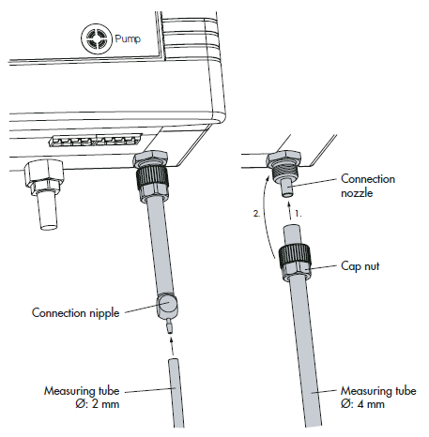  Connecting measuring tube on OTT CBS bubble sensor
- Cut off the end of the measure tube square with a razor blade or sharp knife and push onto the factory fitted connection nipple. The maximum length of the measuring tube is 75 meters for 4mm internal diameter tubing, and 100 meters for 1/8 inch or 2 mm tubing.

Installing the bubble pot | 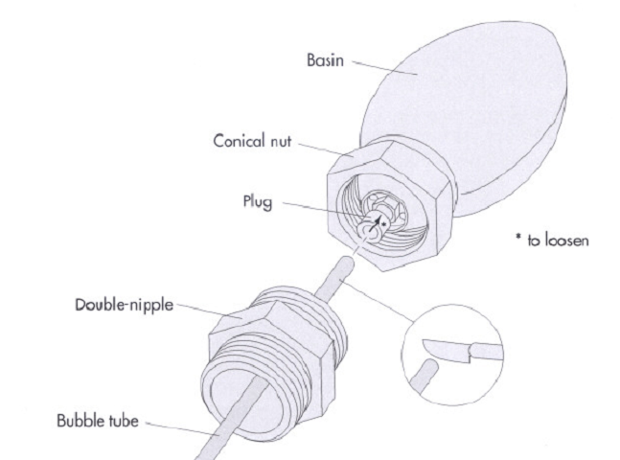  Bubble pot EPS 50
- The bubble pot has to be installed in the direction of the flow.
- Lead the bubble tube through a conduit (metal or plastic) to the place where the bubble pot has to be installed; actually the bubble pot must be completely under water.
Connecting the Bubble pot EPS 50 to the bubble Tube | 1.) Cut the bubble tube right-angled with a sharp blade 2.) Remove double nipple from the bubble pot  3)Insert the tube into the pot and connect the double nipple.
- Cut the bubble tube right-angled with a sharp blade
- Remove double nipple from the bubble pot
- Insert the tube into the pot and connect the double nipple.

Terminal connection | 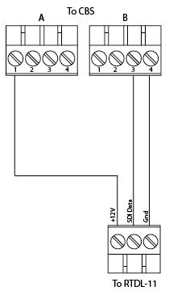  Connecting the OTT CBS to RTDL-11 using an SDI-12 interface
Activating the purge function  (for clearing the measuring tube and the bubble chamber of any minor contamination by pumping air into the measuring tube) | - On the front of the OTT CBS there is a Pump membrane button. Pressing the button activates the purge function for as long as it is pressed. The Status LED lights for approx. 2 seconds. With on activated purge pump function, the CBS pumps a large amount of air through the measuring tube for the required time period. The purge function can also be activated via an SDI-12 command.  - Note: Press the membrane button for at least one second as otherwise the error memory is called and displayed at the status LED.  - Bubbler can also be purged remotely through web.
Trouble Shooting
No response: | - Check Connectivity and voltage
Bubbler pumping forever: | - Should normally stop after 5 min of boot up  - Check if the air is leaking at the ends or at some places in the tube  - Check by stopping the air flow completely at sensor terminal (you should see pumping stop and values equivalent to max observable value, nearly 15 m)
Value Inaccuracy: | - Bubbler gives 0 values for initial 5 min bootup time and gives this value if the tube is leaked (notice the offset set for the water-level before saying it doesn’t give 0 value but a constant value at any depth)  - Value too low than expected (check if there’s a leak in the tube)  - Value too high than expected (check if the tube has been blocked or twisted somewhere, avoid micro bending)
Maintenance
Activating purge function | Activate the purge function of the OTT CBS quarterly by pressing the membrane button Pump and checking whether air bubbles rise out of the bubble chamber. If not, check whether the bubble chamber is blocked, and/or whether the measuring tube is leaking or blocked.
Cleaning bubble chamber | Check the bubble chamber quarterly for sand buildup and weed infiltration. For light sand buildup, clean the bubble chamber using the purge function, and for heavier buildup or weed infiltration clean the bubble chamber carefully manually (do not change the position of the bubble chamber).
Cleaning of bubble pot | 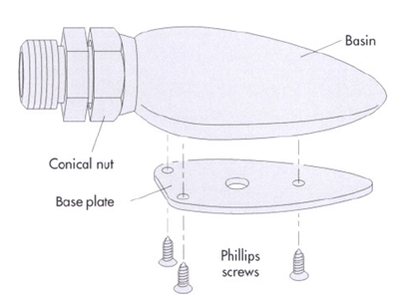  Regularly check the bubble pot –at least once a year- if there is any debris and if it is still correctly aligned. If there are lots of particles or weeds in the water you have to check more frequently.  For cleaning you have to remove the three Phillips screws and the base plate at the bottom of the bubble pot. After cleaning the bubble pot has to be adjusted again to the direction of the flow.
Testing the measuring tube | After 15 years operation, test the measuring tube for tightness/pressure resistance roughly every 2 years.
Manufacturer | OTT Hydromet Gmbh  Ludwigstrasse 16  87437 Kempten  Tel. +49 (0) 831/5617-222  Fax +49 (0) 831/5617-209  info@ott.com  www.ott.com

Tipping Bucket (TB3)
Purpose |  |  | 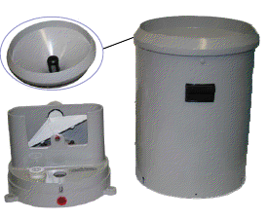Tipping Bucket
The TB3 tipping bucket is used for measuring rainfall and precipitation in remote and unattended areas.
Each unit consists of a collector funnel with leaf filter, an integrated siphon control mechanism, an outer enclosure with quick release fasteners and base which houses the tipping bucket mechanism.
The unit includes dual output reed switches with varistor protection as well as dual rainfall discharge outlets for water collection and analysis.
Site selection |  |  | 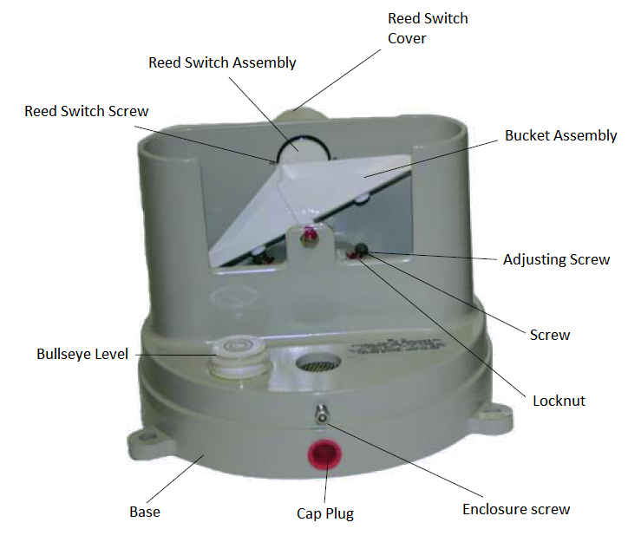
- Remove all the obstacles in the vicinity of the gauge that could create wind effects; the distance of the gauge to obstructing objects should be at least 4 times the height of the obstruction.
- The area surrounding the gauge should be relatively level and the gauge orifice should be horizontal.
- The ground surrounding the gauge should be covered with short grass, equivalent natural vegetation or gravel to avoid splashing of rainfall into the gage; the ground surface around the gage should not be paved.
Terminal connection |  |  | 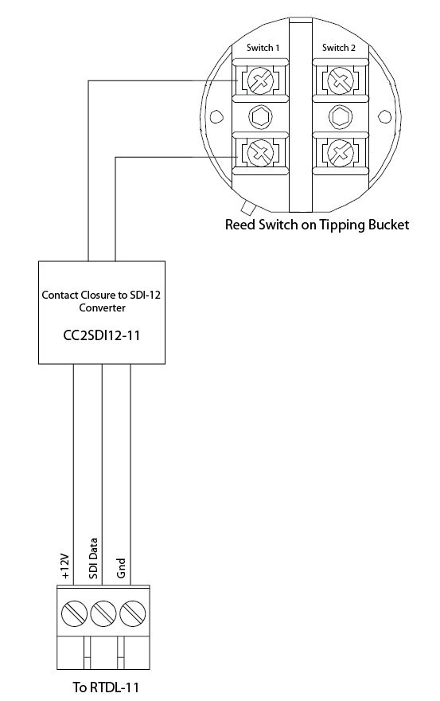
Tipping Bucket uses SDI-12 interface.
Connecting Tipping Bucket to data logger (RTDL-11) requires Contact Closure to SDI-12 Converter (CC2SDI12-11)
Mounting
- The orifice of the tipping bucket must be installed at a height of 1 m from the ground.
- The tipping bucket mounts on a 2-inch pipe. Drive the pipe into the ground to acquire a firm vertical post and use the enclosed hose clamps to mount the gauge to this post.
- Level the gauge after mounting it (use bulls eye level on the tipping bucket)
Maintenance
- Check if the tipping bucket is securely attached to a post and that the post is firmly implanted on the ground.
- Check if the cable from the logger is firmly connected; If necessary clean contacts.
- Check if the funnel and bucket mechanism are clean; remove any leaves, dust, insects or other foreign elements.
- Open the tipping bucket housing every 3 months.
- Check that the tipping bucket assembly operates freely.
- Remove and clean the siphon.
Manufacturer | Hydrological Services Pty Ltd  PO Box 332, Liverpool B.C NSW1871, Australia  Phone :( Int.) 612 9601 2022 Fax: :( Int.) 612 9602 6971  Phone :( Nat.) (02) 9601 2022 Fax: :( Nat.) (02) 9602 6971  Email: sales@hydrologicalservices.com  Web: www.hydrologicalservices.com

OTT Pluvio²
Purpose
The OTT Pluvio² is used for automatic determination of intensity and amount of precipitation. It works using the balance principle. The OTT Pluvio² reliably recognizes precipitation, whether liquid or solid by determining the weight of the collecting bucket.
Mounting | 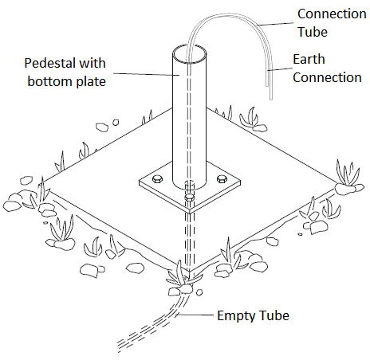
- Make a concrete base and attach the pedestal with the bottom plate to a concrete base.
- Pull connection cable into the empty conduit.
Preparing and installing the Base Plate | 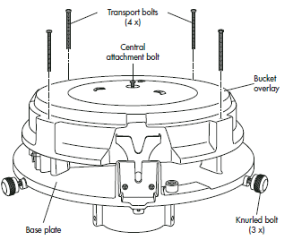.
- Unscrew three knurled screws on the pipe housing. Remove the base plate.
- Remove the four outside cross-head bolts (transport bolts) in the bucket overlay.
- Loosen the central attachment bolt in the bucket overlay and remove the bucket overlay.
- Unscrew four cross-head bolts on the cover of the electronic unit, raise the cover slightly and pull it off forwards.  - Place the base plate onto the pedestal such that the connection and ground cables come out of the slit in the base plate flange and screw. | 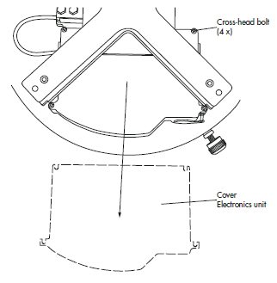
Connecting the connection cable | 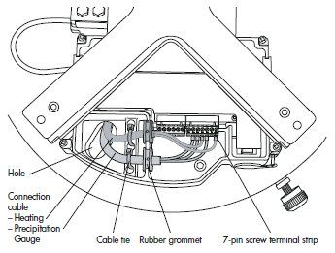
- Feed connection cable through hole in the base plate.
- Push rubber grommet with connection cable into the slot.
Adjusting the base plate | 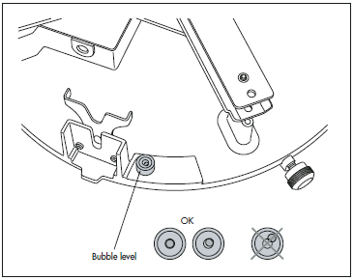  Leveling of Pluvio  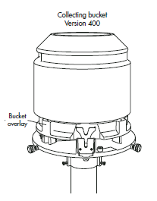  Place collecting bucket onto bucket overlay
- Adjust the base plate with the lower hexagon bolts such that the air bubble in the bubble level is within the marked ring.
- Place the electronics unit cover back on.
- Position bucket overlay
- Place collecting bucket onto bucket overlay.
Terminal connection | 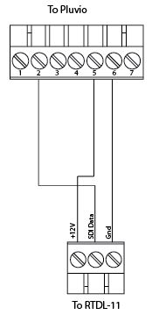
Trouble Shooting
No status LED blinking | Check supply voltage and wiring
Invalid Data | - Check wiring
Maintenance
- Empty the collecting bucket after long periods of precipitation.
- Unscrew the three knurled screws on the pipe housing
- Remove pipe housing
- Carefully remove the collecting bucket and empty it.
- Check the ease of movement of the collecting bucket in all directions at the lower edge of the bucket orifice.
- With the pipe housing closed, move the bucket slightly with a sideways tap on the inside
- Carefully remove contamination, if present
Manufacturer | OTT Hydromet Gmbh  Ludwigstrasse 16  87437 Kempten  Tel. +49 (0) 831/5617-222  Fax +49 (0) 831/5617-209  info@ott.com  www.ott.com

Anemometer –Young Wind Monitor
Purpose | 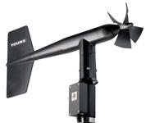
The Wind Monitor Alpine measures horizontal wind speed and direction. A propeller type anemometer records wind speed while the vane moves in the direction of wind. It is rugged and corrosion resistant, yet accurate and light weight.
Site selection
- The site should represent the general area of interest.
- There should be no trees, buildings or other objects situated in the vicinity of the wind sensor.
- The sensor should be higher than any other object within a horizontal radius of 300 m.
Mounting
- Place Wind Monitor on mounting post. Do not tighten band clamp yet.  - Align the wind sensor.  - Align junction box facing south. Use compass.  - Tighten the clamp. | 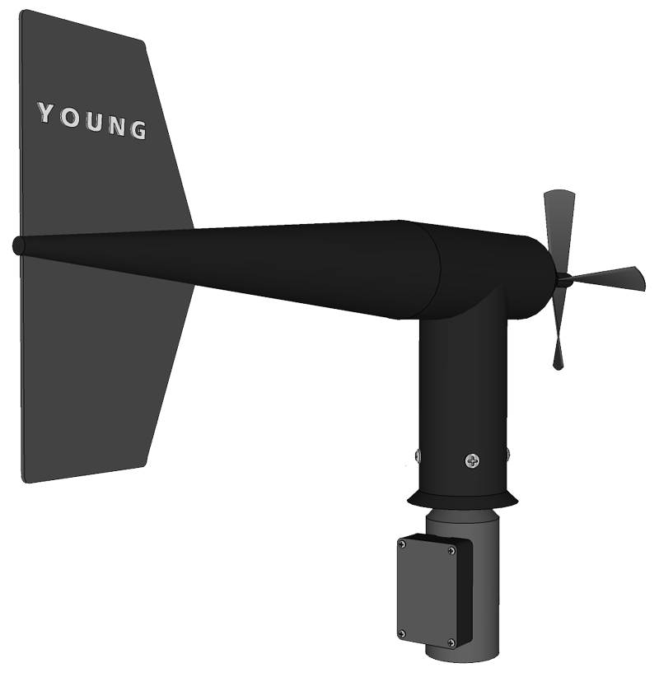  N  S  N
Terminal connection | 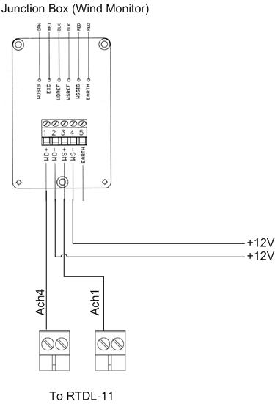
The wind monitor is connected to Analog Channel-1 and Analog Channel-4 of RTDL-11 data logger.

Trouble Shooting
No response from the sensor | Power supply is not sufficient. Check whether the supply is between 9 to 36V.
Invalid Readings | Loose connection of sensor wires. Check for any loose connection or disconnection.
Manufacturer | RM Young Company  2801 AERO PARK DRIVE,  TRAVERSE CITY, MICHIGAN 49686, USA  Tel: (231) 946-3980 Fax: (231) 946-4772  www.youngusa.com

Barometer PTB210
Purpose | 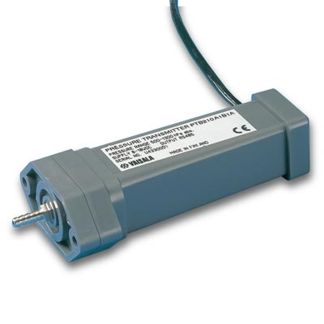
The PTB210 series digital barometers are designed for various pressure ranges. The housing of the barometer electronics provides an IP65 standardized protection against sprayed water. The barometer is digitally adjusted and calibrated by using electronic working standards.
Mounting
- Fix the attachment plate to a desired place (here, inside wall of the DCP box).  - Attach the barometer on the plate with the screws supplied.  - Connect a tube to the Pressure fitting and take the other end of the tube out of the DCP box through gland at the bottom. | 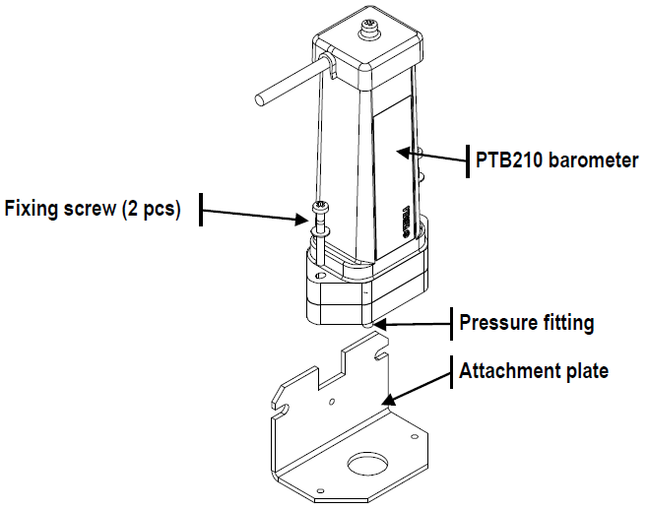  N
Terminal connection | 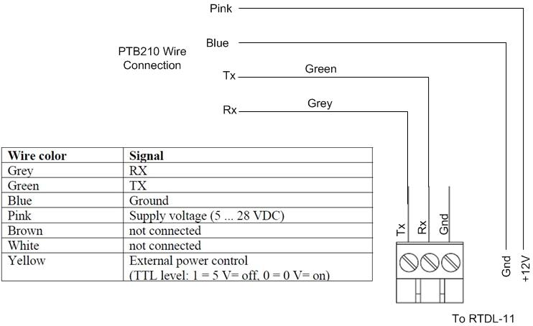
The PTB210 barometric sensor is interfaced through Serial RS232 port of RTDL-11.
Trouble Shooting
No response from the sensor | Power supply is not sufficient. Check whether the supply is between 9 to 36V.
Invalid Readings | Loose connection of sensor wires. Check for any loose connection or disconnection.
Manufacturer | Vaisala Oyj  P.O. Box 26  FI-00421 Helsinki  Finland  Phone: +358-9-8949-1 Fax: +358-9-8949-2227  www.vaisala.com

Barometer PTB330
Purpose |  | 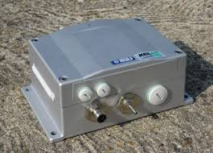
The digital barometer PTB330 provides reliable measurement in a wide range of applications. The barometer can be used successfully both in accurate pressure measurement applications at room temperature and in demanding automatic weather station applications.
Installation |  | 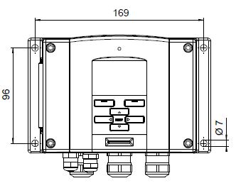
- Mount the housing by fastening the barometer to the wall (DCP Plate) with 4 screws.
Terminal connection | 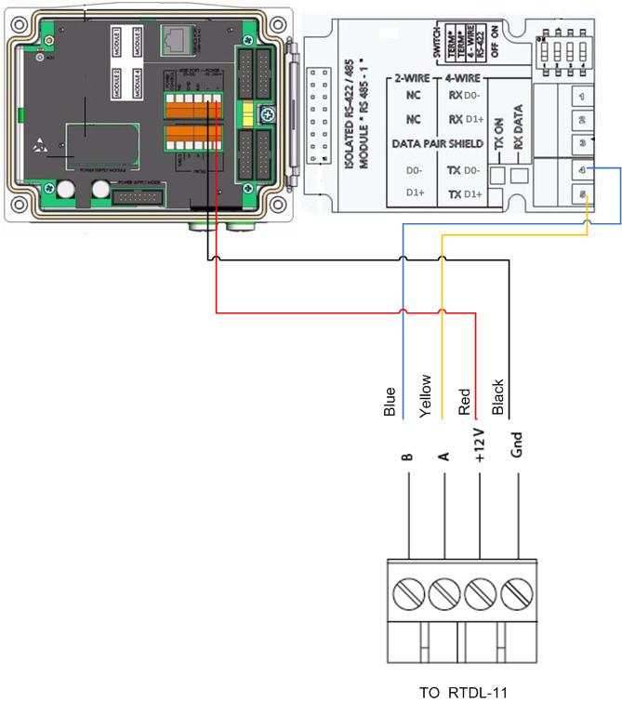  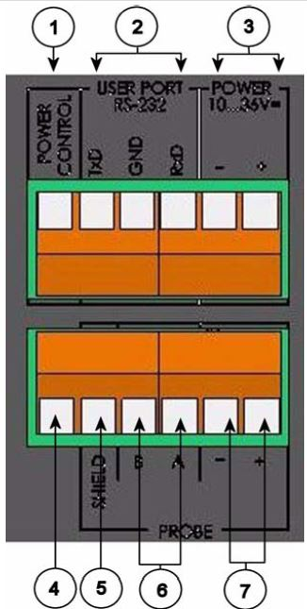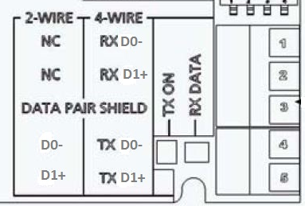  A  B  Gnd  +12V
PTB330 is connected to RS485 Port of RTDL-11
- Open the barometer cover by taking the four cover screws.
- Inset power supply wires and signal wires through the cable bushing in the bottom of the barometer
- Connect the cables as given in figure alongside.
Maintenance
- Clean the barometer enclosure with a soft, lint-free cloth moistened with mild detergent.
Manufacturer | Vaisala Oyj  P.O. Box 26  FI-00421 Helsinki  Finland  Phone: +358-9-8949-1 Fax: +358-9-8949-2227  www.vaisala.com

Temperature / Humidity Sensor - HMP155 with Radiation Shield
Purpose | 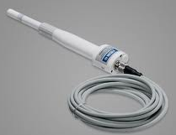 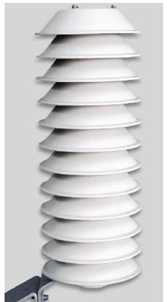 HMP155 Probe Radiation Shield
The HMP155 probe provides reliable humidity and temperature measurement in a wide range of applications. Both the humidity and temperature sensors are located at the tip of the probe, protected by a removable filter.
Installation | 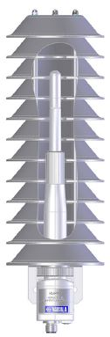  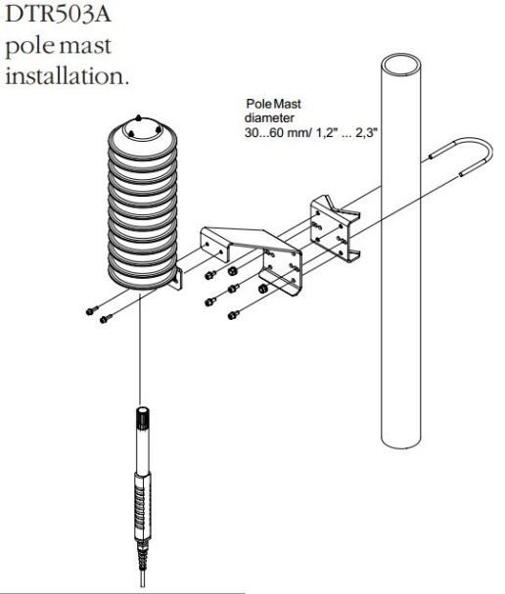
- The HMP155 probe is installed in a radiation shield to reach the maximum performance level.
Terminal connection:  The HMP155 sensor is connected to RS485 port of RTDL-11 | 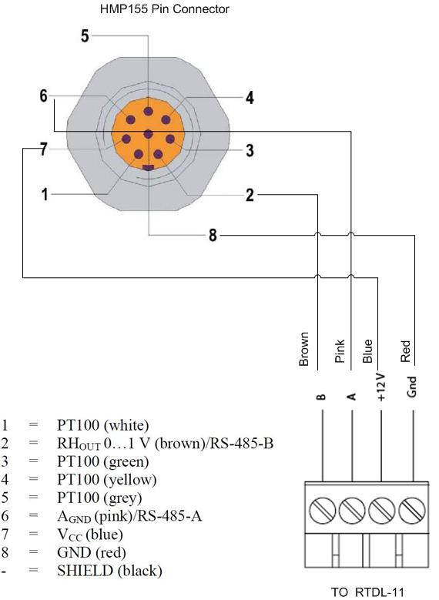
Maintenance
- Clean the probe with a soft, lint-free cloth moistened with mild detergent.
Manufacturer | Vaisala Oyj  P.O. Box 26  FI-00421 Helsinki  Finland  Phone: +358-9-8949-1 Fax: +358-9-8949-2227  www.vaisala.com

Data logger - RTDL-11
Purpose |  |  |  | 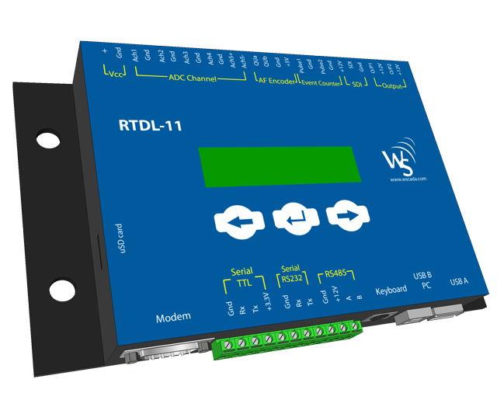
The RTDL-2011 is a small, light, battery or solar powered, portable data logger equipped with microprocessor, internal memory for data storage and sensors.
Any sensor with analogue, digital or SDI channel input can be connected to RTDL-11 which logs the values measured by the sensors and transmits to an internet database server through a communication module.
Getting started with RTDL-11 |  |  |  | - Connect data logger to all the sensors.  - Connect data logger and communication module.  - Turn ‘ON’ the device by plugging in the power cable.  - Install Wscada Configuration Application on your laptop.
Configuring RTDL-11
- Connect USB cable to USB B PC of RTDL-11.  - Open Wscada Configuration Application. |  |  |  | 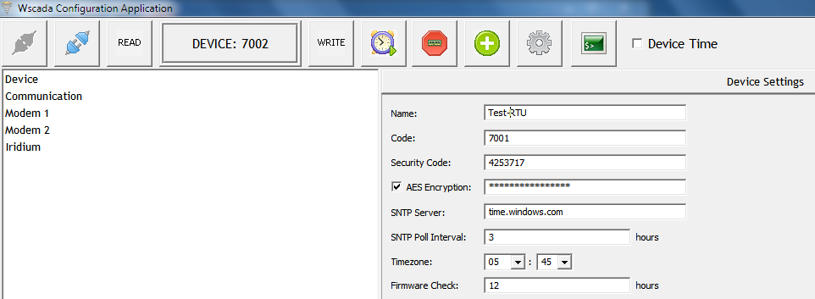
Click connect button |  |  |  | 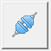
Define Communication Parameters  - Enter the COM Port and Baud Rate. |  |  |  | 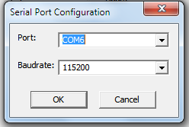
 |  |  | 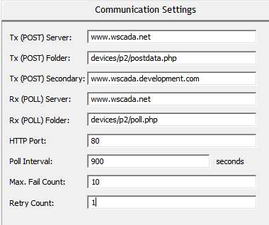
Modem parameters  - The three parameters that define a particular modem are the APN number, username and password. The username and password field are provided by the respective SIM providers. The APN numbers also differ with the SIM service providers. |  |  | 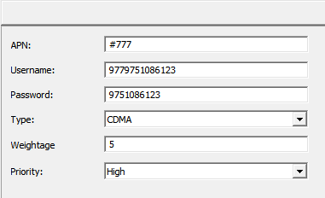
Enabling Iridium  - You can disable or enable iridium for alarm generation or use as regular modem by selecting Mode. |  |  | 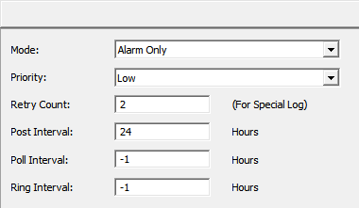
- Click Download.
- Click Query Status to view current data logger settings.

Adding sensors to RTDL-11 through Web Browser
While adding sensor settings to the data logger ensure that the communication module is connected to it. |  | To add sensors to the RTDL-11, login to the domain provided to you and follow the given instructions.  *Note: For more details on using web-based Wscada Configuration, refer to the User’s Manual on RTDL-11.
Click Project |  | 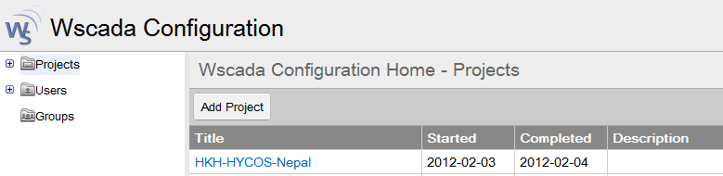
Choose Station |  | 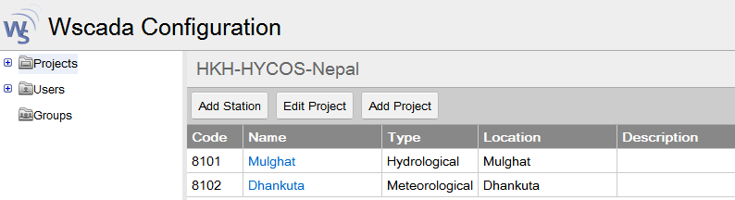
Choose RTU |  | 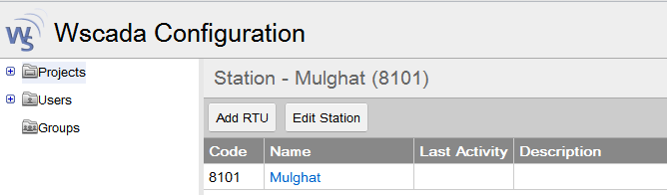
Choose Sensor |  | 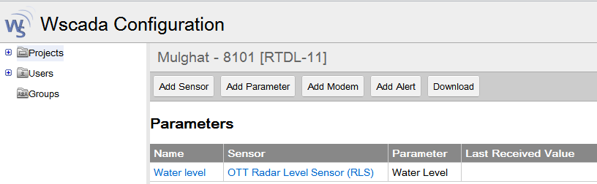
- Click Download.  - Wait for the sensor settings to sync.  - Check for the sensors in the RTDL-11 |  | 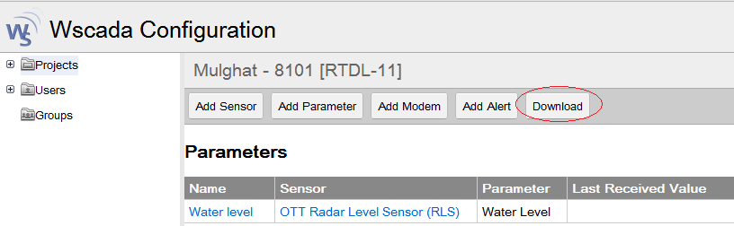
Checking values in data logger
Press the middle (enter) switch for few seconds. You will see screen as shown. |  | 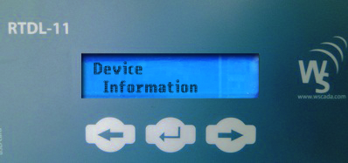
Press right switch |  | 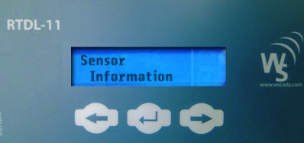
Press Enter switch to view the sensors |  | 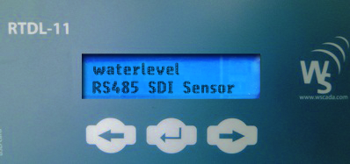
Press left or right switch to view the sensor parameters.  Once required sensor parameter is selected, press Enter switch to view the current data. Press right switch to view other sensor settings. |  | 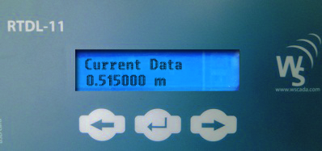
Offset setting for water level
Offset calculation | - Radar Level Sensor  Default: Offset=0  The default values refer to the height at which the RLS is installed from the water surface.  Setting Offset:  Observe the water-level shown by the staff gauge.  Offset = current water level shown by staff gauge + RLS reading  - Compact Bubbler Sensor  Default: Offset = 0  The default values refer to the depth at which the bubbler tube is immersed under the water.  Setting Offset:  Observe the water-level shown by the staff gauge.  Offset = current water level shown by staff gauge - CBS reading  Error Calculation and Offset Setting  After a long run of installation, if there is discrepancy between the true water level and the reading shown by sensor, offset has to be corrected.  Calculate: Error= True water level – Observed water level (i.e. reading shown by RLS or CBS)  Set new offset:  New offset = old offset + error  The offset can be changed either remotely through the web-based interface or locally through laptop using Wscada Configuration Application.
Offset setting using Wscada Application Configuration | - Connect USB cable to USB B PC port of RTDL-11  - Open Wscada Configuration Application on your laptop  - Click Connect Button  - Enter COM Port and Baud Rate  - Click Read on top panel of the application software to read current settings from the datalogger.  - Following messages will appear.  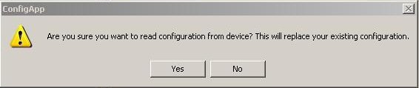  Click Yes.  On the left panel, all the sensors of the datalogger are listed.  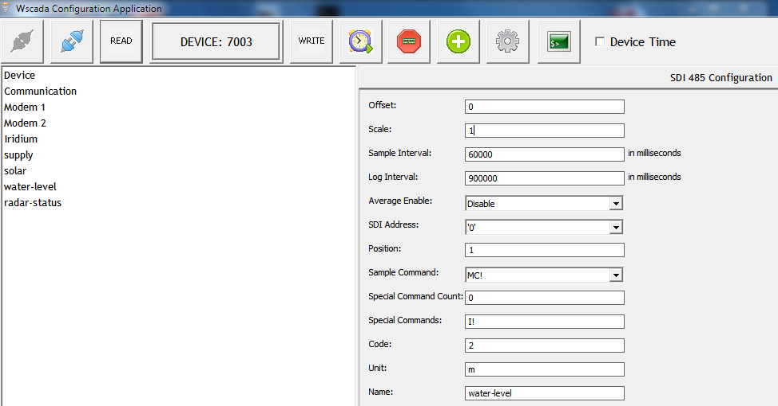  - Select water level.  - Enter offset.  - Click Write to save the settings into the datalogger.
Offset setting through web based interface | - Login to the domain provided to you.  - Select Project> Station> RTU> Sensor> Parameter (i.e waterlevel).  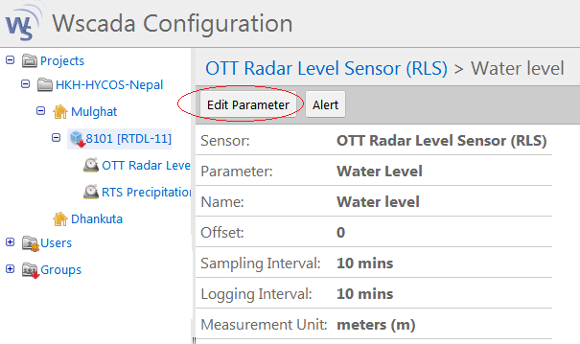  Click “Edit Parmeter”.  - Enter the offset. Click Save.  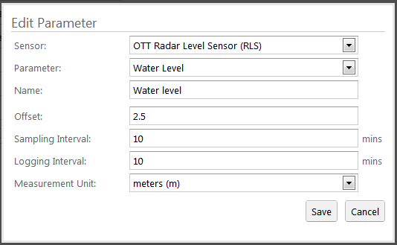
Trouble shooting
Data logger turned off | Check battery voltage. Battery voltage must be greater than 12V.
Data logger is hung | Unplug supply from the data logger and reconnect.
Communication module turned off | Unplug supply from communication module and re-plug.
No Communication | Check connection between data logger and communication module. Check the cable. Replace, if necessary.  Check balance/validity of both RUIM/SIM used. Recharge, if necessary.  Check if RUIM/SIM is inserted into the slots properly. Also check if they are inserted into their respective slots.  Check if antenna is disconnected.  Check the modems  Check for the error codes in datalogger. The following table shows error codes with their meaning and possible causes:  Error Code Description Possible Cause of Error  0 NO_ERROR Normal  1 AT_INIT_UNSUCCESSFUL Modem Malfunctioning  2 PPP_FAILED Low CSQ/Balance Expiration  3 TX_DNS_QUERY_FAILED TX_DNS_QUERY_FAILED  4 RX_DNS_QUERY_FAILED Wrong poll.php url  5 TX_TCP_CONNECT_FAILED  6 RX_TCP_CONNECT_FAILED  7 TX_TCP_DISCONNECT_FAILED  8 RX_TCP_DISCONNECT_FAILED  9 TX_TCP_TRANSFER_FAILED CSQ too low to transfer Actual Data  10 RX_TCP_TRANSFER_FAILED  11 CSQ_FAILED Taking too much time in acquiring CSQ  12 CPIN_READY_FAILED RUIM/SIM Not Detected  13 POST_SUCCESSFUL Everything is Running Smoothly  14 PPP_DISCONNECT_FAILED  15 SEND_SMS_FAILED Illegal Number/Balance Expiration  16 DEL_SMS_FAILED  17 NETWORK_REGISTRATION_FAILED Iridium Antennae Placement and Connection  18 NETWORK_REGISTRATION_QUERY_FAILED  19 CLEAR_SEND_BUFFER_FAILED  20 WRITE_TEXT_FAILED  21 INITIATE_TRANSFER_FAILED  22 READ_BYTES_CHEKSUM_FAILED  23 READ_BYTES_FAILED  34 UDP_TRANSFER_FAILED Wrong Time Server

Recharging RUIM/SIM
There are two different slots for RUIM/SIM in the communication module. For continuous data posting, RUIM/SIM should have fund balance and validity. Thus, RUIM/SIM should be checked at regular interval for balance and validity.  - Unplug power supply from the communication module.  - Pull out RUIM/SIM from the slots.  - Check for balance/validity from your mobile.  - Recharge.  - Insert RUIM/SIM back into their respective slots.  - Re-plug the power supply. |  |  | 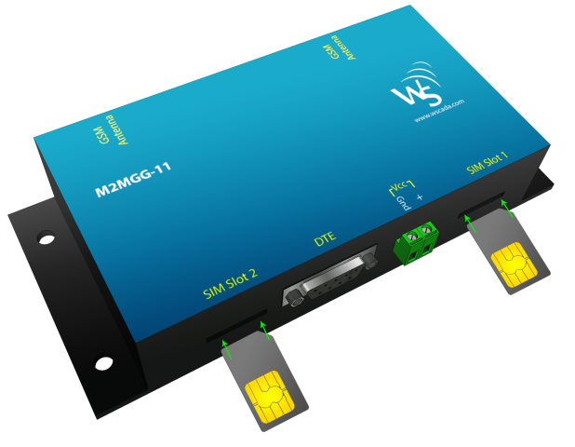
Downloading data from RTDL-2011 |  | Data from RTDL-11 can be downloaded directly using a thumb drive.  - Insert your thumb drive into USB A port of RTDL-11.  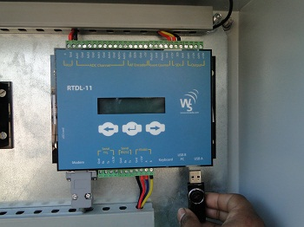  - “Downloading…..” appears on LCD display of the datalogger.  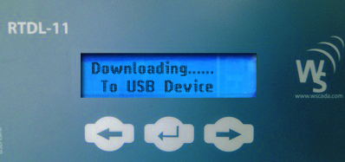  - Wait few seconds for download to complete.  It downloads data of each day in a .csv format into your thumb drive.  - Eject the thumb drive.
Checking and Change of Date and Time on RTDL-2011 Data logger |  | To set data and time in the datalogger:  - Connect RTDL-11 datalogger to Wscada Configuration Application.  - Click “Set Date/Time” on the top panel.  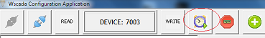
Manufacturer | Real Time Solutions Pvt. Ltd.,  Dhobighat, Patan-44600  Lalitpur, Nepal  Phone: +977-1-5538687 / 5529953 Fax: +977-1-5525695  www.rts.com.np ; www.wscada.com

Field Inspection

Check list for every visit | - Laptop Computer  - Communication cable USB to Serial port  - Shelter key  - Screw diver  - Multi-meter  - Tap meter  - Flashlight (if necessary)  - Pencil  - Field note book  - Etc….
Basic rules | - A global cleaning is necessary around the station (housing especially) to give a secure and good access to the house.  - Inside the house, clean regularly (remove dust, insects…)  - Cut the grass often  - Clean the solar panel once a week  - Remove dust and leaves from the funnel of the rain gauge  - Maintain an open area around the raingauge (cut the branches to avoid covering the raingauge)  - Clean the staff gauges once a month to remove algae and mud  - Open a logbook to note any intervention within the station (visit, setup modification, adjustment of initial values…).  - With the datalogger (RTDL-2011) proceed to the adjustment of the water level if needed (see specific SOP).
Check the battery and solar charger every week
- Test the battery voltage. It should be more than 12.0 Volts.
- Test the solar panel voltage (if a solar panel is fitted). It should be more than battery volts

Clean the solar panel every week | 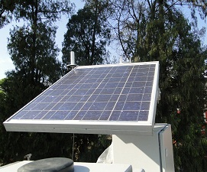
- Clean the solar panel with water and a soft cloth
- Check that the solar panel is not damaged
- Trim any trees that stop sunlight from reaching the solar panel
OTT RLS maintenance: | - Check the OTT RLS for dirt (e.g. thick, dewy spider's webs or insect nests can lead to impairment of the measured results). In this case, carefully clean the sensor (if necessary use commercial, gentle and non-erasing cleaners and a soft sponge). At the same time, ensure that the setting of the swivel mount does not change.  - Check for obstructions in the measurement beam (for example, for flotsam or branches of trees and bushes growing into this area). In this case, remove all obstructions.  - Check the plausibility of the measured values by comparing with a second sensor or with a staff gauge.
Tipping Bucket Maintenance | - Remove dust, leaves or any other foreign elements from the funnel of the tipping bucket.  - Open tipping bucket housing once a week and check if tipping bucket assembly operates freely and clean the siphon.  - While cleaning the tipping bucket push filter and pull siphon at the same time. Do not twist while pushing and pulling.
WXT520 Maintenance | - Remove any leaves, dust or any other contamination on the precipitation sensor.  - Clean with soft cotton cloth.  - Do not rotate, pull, strike, bend, scrape or touch the transducers of WXT520 with sharp objects.

